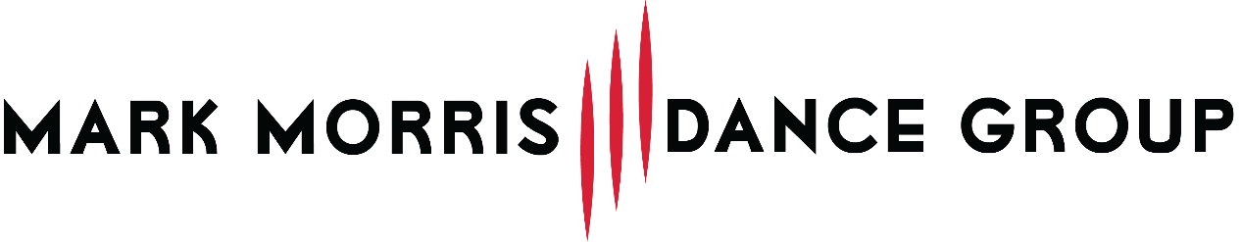

For Immediate Release
Press Contact: Tara Treffiletti, tara.treffiletti@mmdg.org

THE MARK MORRIS DANCE GROUP JOINS FESTIVAL OF NEW YORK

Mark Morris Dance Group and Mark Morris Dance Center to present performances, classes, and special events as part of inaugural Festival of New York

BROOKLYN, NY – The Mark Morris Dance Group (MMDG) has joined a collective of more than 300 organizations spanning the worlds of Culture, Education, Hospitality, Business, Media, Wellness as part of the first Festival of New York – a citywide collaboration to promote New York City’s cultural, economic, and spiritual comeback during the summer of 2022.

Festival of New York is an unprecedented movement to marshal the creativity, resiliency, diversity, and spirit of collaboration that makes New York one of the strongest and most inspiring cities on earth. Kickstarting the summer season, Festival of New York invites anyone and everyone who believes in New York to contribute, take part, and come together as we collectively recover from one of the most difficult periods in our history and see our way through to a kinder, more equitable, more collaborative, and more inclusive future.

During the summer months, Memorial Day through Labor Day, Festival of New York will animate the city
with events and opportunities to honor, grow, rejoice, and give back together through cross-borough
collaborations, performances, installations, family fairs, community service opportunities, participatory arts and culture experiences, career fairs, and more.

In addition to its ongoing classes, camps, and community programs, MMDG will perform and host several special events as part of Festival of New York. On August 18, the Dance Group will perform at the Queens Botanical Garden, the School at the Mark Morris Dance Center and Dance for PD® will present a 20th Anniversary Dance Center Showcase on June 10-12, and together with Downtown Brooklyn Partnership the Dance Center will host Movement Mondays on The Plaza at 300 Ashland throughout the month of June.

[QUOTE FROM NLU?]

For more information about MMDG’s participation, visit mmdg.org, and for a complete list of Festival of New York partners, activations, and events, visit: FestivalofNY.com.

WHAT: Mark Morris Dance Group joins Festival of New York

WHEN/ WHERE: Festival of New York
Memorial Day (May 30) through Labor Day (September 5) 2022
More than 300 venues throughout the 5 boroughs of New York City

Mark Morris Dance Group Performances and Events
June 6, 13, 20 & 27, 2022: Movement Mondays on The Plaza at 300 Ashland
June 10-12, 2022: 20th Anniversary Dance Center Showcase at Mark Morris Dance Center
August 18, 2022: MMDG performance at Queens Botanical Garden in Queens, NY

About the Mark Morris Dance Group and MMDG Music Ensemble
Founded in New York City in 1980 by artistic director and choreographer Mark Morris, praised by The New York Times as “the most successful and influential choreographer alive, and indisputably the most musical,” the Mark Morris Dance Group has been called “the preeminent modern dance organization of our time” (Yo-Yo Ma). Its members have received the “highest praise for their technical aplomb, their musicality, and their sheer human authenticity.” (Bloomberg News). Live music and community engagement are vital components of the Mark Morris Dance Group, which has toured with its own musicians, the MMDG Music Ensemble, since 1996. The Mark Morris Dance Center, opened in Brooklyn in 2001, is the home of the Dance Group and provides educational opportunities in dance and music to people of all ages and abilities.

# # #

